


Technical Specification for Electronic Data Interface

2015.03.18
Ver. 3.4.0

CONTENTS

1. Outline ............................................................................................................... 4
1.1. Communication ...................................................................................................................................... 4
1.2. Abbreviation ............................................................................................................................................ 4
2. Elements of Specification ................................................................................... 4
2.1. Category Description ......................................................................................................................... 4
3. Payment Service ................................................................................................ 8
3.1. Purchase Request ................................................................................................................................. 8
3.3. Refund Request within Network ............................................................................................. 15
3.4. Capture Confirmation Request ................................................................................................. 18
3.5. 3D Secure Request ........................................................................................................................... 19
4. Data Encryption ............................................................................................... 23
4.1. Credit Card Data Encryption ....................................................................................................... 23
4.2. Forgery/Alteration Data Verification.................................................................................... 24
APPENDIX I. Response Code/Message ................................................................ 27

Document History
Date | Version | Description | Note
2014.09.17 | 1.0.0 | Initial Completion
2014.10.15 | 3.0.0 | Add to Web server error code
2014.12.23 | 3.0.1 | 4.2.4 Sample Source annotation added
2015.02.17 | 3.1.1 | Specification Detail amended and ONPEX error code added
2015.02.26 | 3.1.4 | Visa3D Specification detail added
2015.03.13 | 3.2.0 | Purchaser field length amended
2015.03.13 | 3.3.0 | GOMPAY error code added
2015.03.18 | 3.4.0 | Response field start value deleted and response code amended

1. Outline
The following Specification is designed to integrate international payment services with ease

1.1. Communication
Communication between Merchant’s server and Payment Gateway’s server is operated by HTTPS protocol. Request Data form is utilized by Form parameter and sent in POST method. Response Data uses string type categorized in specific string, JSON and XML.

1.2. Abbreviation
Category | Description
AN | Alphanumeric
N | Numeric
M | Mandatory
O | Option
C | Conditionally Mandatory
V | Variable data length

2. Elements of Specification
2.1. Category Description

2.1.1. “?” (Start Request)
Starting point of Request

2.1.2. Ver
Module version of current integration. Current version is “1000”

2.1.3. RequestType
Value to differentiate Service Request
Value | Description
TRAN | Purchase/Refund/Capture Confirmation Request

2.1.4 MID
Smartro’s Merchant ID to categorize merchants in service types. Eg) mcausa840m

2.1.5. TransactionType
Value to differentiate transaction type such as Authorization/Refund/Capture Request
Value | Description
AA | Authorization
AC | Refund

AD | Refund within Network
AQ | Real-time Capture Request
AS | Verification Approval
SQ | 3D Secure Verification Approval

2.1.6. Reference
Created to differentiate transactions requested by Merchant. Merchant creates and sets Reference at Purchase Request.
The value must be unique and its 4 digits above from the end must be in numbers.
※ The last 4 digits of the data are used in Encryption/Decryption and Forgery/Alteration Verification
※ Reference value when Refund within network is set equivalent to when requesting purchase

2.1.7. Currency
Currency Code on Purchase/Refund Request
Value | Description | Amount Setting | Remarks
JPY | Japanese Yen | 12.2 ⇒ 12 12.5 ⇒ 13
USD | US Dollar | 12 ⇒ 12.00 12.356 ⇒ 12.36
EUR | Euro | 12 ⇒ 12.00 12.356 ⇒ 12.36
HKD | Hong Kong Dollar | 12 ⇒ 12.00 12.356 ⇒ 12.36
GBP | British Pound | 12 ⇒ 12.00 12.356 ⇒ 12.36
SGD | Singapore Dollar | 12 ⇒ 12.00 12.356 ⇒ 12.36
AUD | Australian Dollar | 12 ⇒ 12.00 12.356 ⇒ 12.36
THB | Thailand Baht | 12 ⇒ 12.00 12.356 ⇒ 12.36
CAD | Canadian Dollar | 12 ⇒ 12.00 12.356 ⇒ 12.36
RUB | Russian Dollar | 12 ⇒ 12.00 12.356 ⇒ 12.36
CNY | Chinese Yuan | 12 ⇒ 12.00 12.356 ⇒ 12.36

2.1.8. Amount
Amount for Purchase/Refund request. When Partial Refund, amount must be smaller than original transaction amount
2.1.7. Must follow Currency amount setting form

2.1.9. CardNumber
Credit Card Number. Currently VISA, MASTER and JCB valid
※ AES-128 bit encryption required. [Refer 4.1. Credit Card Data Encryption]

2.1.10. ExpiryYYMM
Credit Card expiry date. Year 2 digit + Month 2 digit form requested when setup
※ AES-128 bit encryption required. [Refer 4.1. Credit Card Data Encryption]

2.1.11. CVC
Card Verification Value Code. 3 digit numbers when VISA,MASTER or JCB
※ AES-128 bit encryption required. [Refer 4.1. Credit Card Data Encryption]

2.1.12. AcquireType
Capture type per purchase. Smartro proceeds capture process after purchase for automatic capture. Merchant needs to make separate capture request for manual capture
Value | Description
1 | Automatic Capture
2 | Manual Capture

2.1.13. ProductName
Product Name of Purchase

2.1.14. BuyerEmail
Buyer’s E-mail address

2.1.15. BuyerName
Buyer’s Name as specified on Credit Card FirstName +'-'+ LastName eg> hong-gildong

2.1.16. BuyerID
Buyer’s ID managed by Merchant

2.1.17. BuyerIP
Buyer’s IP address in device when purchase

2.1.18. OutputType
Value for Output Data Type. Currently provided Output Types are Character String, JSON, XML format categorized in Delimiter
Value | Description
D | Categorized into !@# Delimiters for output
J | Response Data Output in JSON format
X | Response Data Output in XML format

2.1.19. VerifyValue
Value to verify whether value sent from Merchant to Smartro and/or from Smartro to Merchant is forged and/or altered.
Method to create Verification Data is by using specific Value Type with Delimiter as shown in table below.
※ Any occurring error while creating Verification Value, the value will be set to “NULL”.
[Refer 4.2. Forgery/Alteration data verification]
Transactio | Classificatio | Verification Data

n Type | n
AA | Request | Reference+[Delimiter]+Amount+[Delimiter]+MID+ [Delimiter]+AcquireType
 | Response | Reference+[Delimiter]+MID+[Delimiter]+ResponseCode+ [Delimiter]+TID+[Delimiter]+ResponseDate+[Delimiter]+ ResponseTime
AC | Request | Reference+[Delimiter]+MID+[Delimiter]+TID+ [Delimiter]+Amount+[Delimiter]+PartialCancelCode
 | Response | Reference+[Delimiter]+MID+[Delimiter]+ResponseCode+ [Delimiter]+TID+[Delimiter]+ResponseDate+[Delimiter]+ ResponseTime
AD | Request | Reference+[Delimiter]+MID+[Delimiter]+Amount+ [Delimiter]+AuthDate
 | Response | Reference+[Delimiter]+MID+[Delimiter]+ResponseCode+ [Delimiter]+TID+[Delimiter]+ResponseDate+[Delimiter]+ ResponseTime
AQ | Request | Reference+[Delimiter]+MID+[Delimiter]+TID+ [Delimiter]+Amount
 | Response | Reference+[Delimiter]+MID+[Delimiter]+ResponseCode+ [Delimiter]+TID+[Delimiter]+ResponseDate+[Delimiter]+ ResponseTime
SQ | Request | Reference+[Delimiter]+Amount+[Delimiter] ]+MID+ [Delimiter]+TransactionType
 | Response | Reference+[Delimiter]+MID+[Delimiter]+ResponseCode+ [Delimiter]+TID+[Delimiter]+ResponseDate+[Delimiter]+ ResponseTime

2.1.20. ResponseCode
Response Code [ Refer APPENDIX I ]

2.1.21. ResponseMessage
Response Message [ Refer APPENDIX I ]

2.1.22. ResponseDate
Response Date. Purchase Date in YYYYMMDD format

2.1.23. ResponseTime
Response Time. Purchase Time in HH24MISS format

2.1.24. TID
Purchase Transaction ID created by Smartro. Required when requesting Refund and/or Capture

2.1.25. AuthCode
Purchase Authorization Code (Number). Required when requesting Refund and/or Capture

2.1.26. PartialCancelCode
Refund Type. Full amount or Partial Amount Refund.
Value | Description

0 | Full Amount refund request
1 | Partial Amount refund request

2.1.27. ServiceType
Henceforth, Service type to be used in separate value. Currently fixed to A

2.1.28. AuthDate
Original Transaction Date

2.1.29. ServerIP
Merchant Server’s Official IP

2.1.30. SiteURL
Merchant’s online mall URL

3. Payment Service
3.1. Purchase Request
3.1.1. Description
Request purchase to be processed

3.1.2. HTTPS Request
No | Field Name | Type | Length | Condition | Description
1 | ? | AN | 1 | M | Start Request Refer to 2.1.1.
2 | Ver | AN | 4 | M | 1000 fixed Refer to 2.1.2.
3 | RequestType | AN | 4 | M | Request Type Refer to 2.1.3.
4 | MID | AN | 10 | M | Merchant ID Refer to 2.1.4.
5 | TransactionType | AN | 2 | M | Transaction Type Refer to 2.1.5.
6 | Reference | AN | 20 | M | Transaction reference number (Unique) Refer to 2.1.6.
7 | Currency | AN | 3 | M | Currency Type Refer to 2.1.7.
8 | Amount | AN | 12 | M | Transaction Amount Refer to 2.1.8.
9 | CardNumber | V | - | M | Card Number Refer to 2.1.9.
10 | ExpiryYYMM | V | - | M | Expiry Date Refer to 2.1.10.
11 | CVC | V | - | M | CVC Refer to 2.1.11.
12 | AcquireType | AN | 1 | M | Acquiring Type Refer to 2.1.12.

13 | ProductName | AN | 100 | O | Product Name Refer to 2.1.13.
14 | BuyerEmail | AN | 60 | O | Buyer’s E-mail Address Refer to 2.1.14.
15 | BuyerName | AN | 31 | O | Buyer’s Name Refer to 2.1.15.
16 | BuyerID | AN | 20 | O | Buyer’s ID Refer to 2.1.16.
17 | BuyerIP | AN | 40 | M | Buyer’s IP Refer to 2.1.17.
18 | ServerIP | AN | 40 | M | Merchant Server IP (Official IP) Refer to 2.1.29.
19 | SiteURL | AN | 200 | M | Merchant URL Refer to 2.1.30.
20 | OutputType | AN | 1 | M | Output Format Refer to 2.1.18.
21 | VerifyValue | V | - | M | Verification Value Refer to 2.1.19.
22 | Pares | AN | 6k | O | Length of 4~6k byte when RequestType value is AS

Example 1: * Credit Card Data unencrypted

Request Start | ?
Ver | 1000
RequestType | TRAN
MID | mcausa840m
TransactionType | AA
Reference | MERCHANT00001234
Currency | USD
Amount | 100.99
CardNumber | 4141414141414141
ExpiryYYMM | 1711
CVC | 125
AcquireType | 1
ProductName | PRODUCT
BuyerEmail | test@test.com
BuyerName | TEST
BuyerID | TEST
BuyerIP | 211.123.123.123
ServerIP | 209.121.111.2
SiteURL | https://www.aaaaaaaa.com
OutputType | X
VerifyValue | OGJiMGNmNmViOWIxN2QwZjdkMjJiNDU2ZjE yMTI1N2RjMTI1NGUxZjAxNjY1MzcwNDc2Mzg zZWE3NzZkZjQxNA==
Pares | ?

Example 2: * Credit Card Data encrypted
Request Start | ?
Ver | 1000
RequestType | TRAN
MID | mcausa840m
TransactionType | AA
Reference | MERCHANT00003783
Currency | USD
Amount | 10.84
CardNumber | 66VwxV18yJtMpx2ynJrituttHeqF4+B/hiN+Wu9uFLY=
ExpiryYYMM | hKWRom2bQB0M1LQWACKwsg==
CVC | 8LfzGlCzvohr3On8Uf+yhg==
AcquireType | 2
ProductName | PRODUCT
BuyerEmail | test@test.com
BuyerName | TEST
BuyerID | TESTID
BuyerIP | 211.123.123.122
OutputType | X
VerifyValue | TUVSQ0hBTlQwMDAwMTIzNA==w2LMTAuODQ=/wZbWN hdXNhODQwbQ==+mDMQ==
Pares | ?

3.1.3. Response
No | Field Name | Type | Length | Condition | Description
1 | Ver | AN | 4 | M | 1000 fixed Refer to 2.1.2.
2 | RequestType | AN | 4 | M | Request Type Refer to 2.1.3.
3 | MID | AN | 10 | M | Merchant ID Refer to 2.1.4.
4 | TransactionType | AN | 2 | M | Transaction Type Refer to 2.1.5.
5 | Reference | AN | 20 | M | Transaction Reference Number (Unique) Refer to 2.1.6.
6 | ResponseCode | AN | 4 | M | Response Code Refer to 2.1.20.
7 | ResponseMessage | AN | 100 | M | Response Message Refer to 2.1.21.
8 | ResponseDate | AN | 8 | M | Transaction Date YYYYMMDD Refer to 2.1.22.
9 | ResponseTime | AN | 6 | M | Transaction Time HHMMSS Refer to 2.1.23.
10 | TID | AN | 30 | M | Smartro’s Transaction Number (Unique) Refer to 2.1.24.
11 | AuthCode | AN | 12 | M | Authorization Number Refer to 2.1.25.
12 | VerifyValue | V | - | M | Verification Value Refer to 2.1.19.

Example 1:

<Response>
<Ver>1000</Ver>
<RequestType>TRAN</RequestType>
<MID>mcausa840m</MID>
<TransactionType>AA</TransactionType>
<Reference>MERCHANT00001234</Reference>
<ResponseCode>0000</ResponseCode>
<ResponseMessage>Processing Valid</ResponseMessage>
<ResponseDate>20140927</ResponseDate>
<ResponseTime>164500</ResponseTime> <TID>mcausa840m01011409271743213011</TID>
<AuthCode>00417432</AuthCode>
<VerifyValue>
NjNjMmM1YTUzOTU4MzRlZjQxZjJmZDA5ZTAxMDdiZG
MxZGNhNzIwODJlMjg1MTNiYTNjY2FlNTQwNzkxMTAwMA==
</VerifyValue>
</Response>

Example 2:

<Response>
<Ver>1000</Ver>
<RequestType>TRAN</RequestType>
<MID>mcausa840m</MID>
<TransactionType>AA</TransactionType>
<Reference>MERCHANT00003783</Reference>
<ResponseCode>E917</ResponseCode>
<ResponseMessage>Card Number Error</ResponseMessage>
<ResponseDate>20140927</ResponseDate>
<ResponseTime>164500</ResponseTime> <TID>mcausa840m01011409271743213012</TID>
<AuthCode></AuthCode>
<VerifyValue>
OWJkZWY0YTJkYTM2ZDRmYzgyYzI4MDAzZWY4OTdhMDFhNW
Y0NDAzZjA0OTFjYmQ5NjZlMGVmYTBmYjdhZjk4Zg==
</VerifyValue>
</Response>

3.2. Refund Request
3.2.1. Description
Request for Refund to process.
3.2.2. HTTPS Request
No | Field Name | Type | Length | Condition | Description
1 | ? | AN | 1 | M | Start Request Refer to 2.1.1.
2 | Ver | AN | 4 | M | 1000 Fixed Refer to 2.1.2.
3 | RequestType | AN | 4 | M | Request Type Refer to 2.1.3.

4 | MID | AN | 10 | M | Merchant ID Refer to 2.1.4.
5 | TransactionType | AN | 2 | M | Transaction Type Refer to 2.1.5.
6 | Reference | AN | 20 | M | Transaction Reference Number (Unique) Refer to 2.1.6.
7 | Currency | AN | 3 | M | Currency Refer to 2.1.7.
8 | Amount | AN | 12 | M | Refund request amount Refer to 2.1.8.
9 | TID | AN | 30 | M | Smartro’s Transaction Number Refer to 2.1.24.
10 | AuthDate | AN | 8 | M | Authorization Date Refer to 2.1.28.
11 | AuthCode | AN | 12 | M | Authorization Number Refer to 2.1.25.
12 | PartialCancelCode | AN | 1 | M | Whether Partial Refund or full Refer to 2.1.26.
13 | OutputType | AN | 1 | M | Output Format Refer to 2.1.18.
14 | VerifyValue | V | - | M | Verification Value Refer to 2.1.19.

Example 1:
Request Start | ?
Ver | 1000
RequestType | TRAN
MID | mcausa840m
TransactionType | AC
Reference | MERCHANT00001246
Currency | USD
Amount | 100.99
TID | mcausa840m01011409271743213011
AuthDate | 20140927
AuthCode | 00417432
PartialCancelCode | 0
OutputType | X
VerifyValue | MTNkNTZlNTE1MzI0YWQ1OTE4MjA2YWU1 MzAwNmIyYmVjMmRmN2I0MWQ4N2RjOWE3 YjU4Zjg5ZTAzYTk4OWU0NA==

Example 2:
Request Start | ?
Ver | 1000
RequestType | TRAN
MID | mcausa840m
TransactionType | AC
Reference | MERCHANT00001246

Currency | USD
Amount | 50.99
TID | mcausa840m01011409271743213011
AuthDate | 20140927
AuthCode | 00417432
PartialCancelCode | 1
OutputType | X
VerifyValue | N2RmODE4NzRiOWIwZjRiYjViZDdlNTJh YjY0ZTllOTMzYWQ2YWJkNWRiM2M1NjVl MDY2NDU2NTQ4ZGRmM2Y4Yw==

3.2.3. Response
No | Field Name | Type | Length | Condition | Description
1 | Ver | AN | 4 | M | 1000 Fixed Refer to 2.1.2.
2 | RequestType | AN | 4 | M | Request Type Refer to 2.1.3.
3 | MID | AN | 10 | M | Merchant ID Refer to 2.1.4.
4 | TransactionType | AN | 2 | M | Transaction Type Refer to 2.1.5.
5 | Reference | AN | 20 | M | Transaction Reference Number (Unique) Refer to 2.1.6.
6 | ResponseCode | AN | 4 | M | Response Code Refer to 2.1.20.
7 | ResponseMessage | AN | 100 | M | Response Message Refer to 2.1.21.
8 | ResponseDate | AN | 8 | M | Transaction Date Refer to 2.1.22.
9 | ResponseTime | AN | 6 | M | Transaction Time Refer to 2.1.23.
10 | TID | AN | 30 | M | Smartro’s Transaction Number (Unique) Refer to 2.1.24.
11 | AuthCode | AN | 12 | M | Authorization Number (Origin Transaction Authorization Number) Refer to 2.1.25.
12 | VerifyValue | V | - | M | Verification Value Refer to 2.1.19.

Example 1:

<Response>
<Ver>1000</Ver>
<RequestType>TRAN</RequestType>
<MID>mcausa840m</MID>
<TransactionType>AC</TransactionType>
<Reference> MERCHANT00001246</Reference>
<ResponseCode>0000</ResponseCode>
<ResponseMessage>Processing Valid</ResponseMessage>
<ResponseDate>20140928</ResponseDate>
<ResponseTime>112500</ResponseTime> <TID>mcausa840m01011409271743213011</TID>
<AuthCode>00417432</AuthCode>
<VerifyValue>
NThkNjI4ZTgzM2FjNjJlYzk3ZjdlNTc1NGM1M2MyZmUwN2I
5MGU5ZDQ1Zjk4YzdhZjhiMDFmNTlkMDM3NTIxZg==
</VerifyValue>
</Response>

Example 2:

<Response>
<Ver>1000</Ver>
<RequestType>TRAN</RequestType>
<MID>mcausa840m</MID>
<TransactionType>AC</TransactionType>
<Reference>MERCHANT00001246</Reference>
<ResponseCode>E903</ResponseCode>
<ResponseMessage>Transaction Date mismatch</ResponseMessage>
<ResponseDate>20140928</ResponseDate>
<ResponseTime>112500</ResponseTime> <TID>mcausa840m01011409271743213011</TID>
<AuthCode>00417432</AuthCode>
<VerifyValue>
NzFiMGE5MDI5YTg0MWUzNjIwNGIxMGM3ZjM5ZDI5NmRlY
mRiODE1YmQ1NGIyMjQ4MTk3ZDQ4ZWY0ZTM0MTMxNg==
</VerifyValue>
</Response>

3.3. Refund Request within Network
3.3.1. Description
Refund is requested with enforcement when Merchant does not receive response on purchase request.

3.3.2. HTTPS Request
No | Field Name | Type | Length | Condition | Description
1 | ? | AN | 1 | M | Start Request Refer to 2.1.1.
2 | Ver | AN | 4 | M | 1000 Fixed Refer to 2.1.2.
3 | RequestType | AN | 4 | M | Request Type Refer to 2.1.3.
4 | MID | AN | 10 | M | Merchant ID Refer to 2.1.4.
5 | TransactionType | AN | 2 | M | Transaction Type Refer to 2.1.5.
6 | Reference | AN | 20 | M | Transaction Reference Number (Unique) Refer to 2.1.6.
7 | Currency | AN | 3 | M | Currency Refer to 2.1.7.
8 | Amount | AN | 12 | M | Refund Request Amount Refer to 2.1.8.
9 | AuthDate | AN | 8 | M | Origin Transaction Authorization Date Refer to 2.1.28.
10 | OutputType | AN | 1 | M | Output Format Refer to 2.1.18.
11 | VerifyValue | V | - | M | Verification Value Refer to 2.1.19.

Example 1:
Request Start | ?
Ver | 1000
RequestType | TRAN
MID | mcausa840m
TransactionType | CC
Reference | MERCHANT00001246
Currency | USD
Amount | 100.99
AuthDate | 20140927
OutputType | X
VerifyValue | MTNkNTZlNTE1MzI0YWQ1OTE4MjA2YWU1 MzAwNmIyYmVjMmRmN2I0MWQ4N2RjOWE3 YjU4Zjg5ZTAzYTk4OWU0NA==

Example 2:
Request Start | ?
Ver | 1000
RequestType | TRAN
MID | mcausa840m
TransactionType | CC
Reference | MERCHANT00001246
Currency | USD
Amount | 100.99
AuthDate | 20140927
OutputType | X
VerifyValue | N2RmODE4NzRiOWIwZjRiYjViZDdlNTJh YjY0ZTllOTMzYWQ2YWJkNWRiM2M1NjVl MDY2NDU2NTQ4ZGRmM2Y4Yw==

3.3.3. Response
No | Field Name | Type | Length | Condition | Description
1 | Ver | AN | 4 | M | 1000 Fixed Refer to 2.1.2.
2 | RequestType | AN | 4 | M | Request Type Refer to 2.1.3.
3 | MID | AN | 10 | M | Merchant ID Refer to 2.1.4.
4 | TransactionType | AN | 2 | M | Transaction Type Refer to 2.1.5.
5 | Reference | AN | 20 | M | Transaction Reference Number (Unique) Refer to 2.1.6.
6 | ResponseCode | AN | 4 | M | Response Code Refer to 2.1.20.
7 | ResponseMessage | AN | 100 | M | Response Message Refer to 2.1.21.
8 | ResponseDate | AN | 8 | M | Transaction Date Refer to 2.1.22.
9 | ResponseTime | AN | 6 | M | Transaction Time Refer to 2.1.23.

10 | TID | AN | 30 | M | Smartro’s Transaction Number (Unique) Refer to 2.1.24.
11 | AuthCode | AN | 12 | M | Authorization Number (Original Transaction Authorization Number) Refer to 2.1.25.
12 | VerifyValue | V | - | M | Verification Value Refer to 2.1.19.

Example 1:

<Response>
<Ver>1000</Ver>
<RequestType>TRAN</RequestType>
<MID>mcausa840m</MID>
<TransactionType>CC</TransactionType>
<Reference> MERCHANT00001246</Reference>
<ResponseCode>0000</ResponseCode>
<ResponseMessage>Processing Valid</ResponseMessage>
<ResponseDate>20140928</ResponseDate>
<ResponseTime>112500</ResponseTime> <TID>mcausa840m01011409271743213011</TID>
<AuthCode>00417432</AuthCode>
<VerifyValue>
NThkNjI4ZTgzM2FjNjJlYzk3ZjdlNTc1NGM1M2MyZmUwN2I
5MGU5ZDQ1Zjk4YzdhZjhiMDFmNTlkMDM3NTIxZg==
</VerifyValue>
</Response>

Example 2:

<Response>
<Ver>1000</Ver>
<RequestType>TRAN</RequestType>
<MID>mcausa840m</MID>
<TransactionType>AC</TransactionType>
<Reference>MERCHANT00001246</Reference>
<ResponseCode>E903</ResponseCode>
<ResponseMessage>Transaction Date mismatch</ResponseMessage>
<ResponseDate>20140928</ResponseDate>
<ResponseTime>112500</ResponseTime> <TID>mcausa840m01011409271743213011</TID>
<AuthCode>00417432</AuthCode>
<VerifyValue>
NzFiMGE5MDI5YTg0MWUzNjIwNGIxMGM3ZjM5ZDI5NmRlY
mRiODE1YmQ1NGIyMjQ4MTk3ZDQ4ZWY0ZTM0MTMxNg==
</VerifyValue>
</Response>

3.4. Capture Confirmation Request
3.4.1. Description
Request for Capture to be processed. (Usage of following part of Specification requires additional agreement/discussion)

3.4.2. HTTPS Request
No | Field Name | Type | Length | Condition | Description
1 | ? | AN | 1 | M | Start Request Refer to 2.1.1.
2 | Ver | AN | 4 | M | 1000 Fixed Refer to 2.1.2.
3 | RequestType | AN | 4 | M | Request Type Refer to 2.1.3.
4 | MID | AN | 10 | M | Merchant ID Refer to 2.1.4.
5 | TransactionType | AN | 2 | M | Transaction Type Refer to 2.1.5.
6 | Reference | AN | 20 | M | Transaction Reference Number (Unique) Refer to 2.1.6.
7 | TID | AN | 30 | M | Smartro’s Transaction Number Refer to 2.1.24.
8 | AuthDate | AN | 8 | M | Original Transaction Date Refer to 2.1.28.
9 | AuthCode | AN | 15 | M | Original Authorization Number Refer to 2.1.25.
10 | ServiceType | AN | 1 | M | A Fixed Value Refer to 2.1.27.
11 | OutputType | AN | 1 | M | Output Format Refer to 2.1.18.
12 | VerifyValue | V | - | M | Verification Value Refer to 2.1.19.

Example 1:
Request Start | ?
Ver | 1000
RequestType | TRAN
MID | mcausa840m
TransactionType | AQ
Reference | MERCHANT00001234
TID | mcausa840m01011409271743213011
AuthDate | 20140927
AuthCode | 00417432
ServiceType | A
OutputType | X
VerifyValue | ZDJjYjYxNTU2ZDU3YmIzMGJiY2NmMjM 3NzYzN2Q4ZDg5MWMxZmQ3MmIzNjdl NDcyZGE3MzgzYTA0NTdlYTVlNA==

3.4.3. Response
No | Field Name | Type | Length | Condition | Description
1 | Ver | AN | 4 | M | 1000 Fixed Refer to 2.1.2.
2 | RequestType | AN | 4 | M | Request Type Refer to 2.1.3.
3 | MID | AN | 10 | M | Merchant ID Refer to 2.1.4.
4 | TransactionType | AN | 2 | M | Transaction Type Refer to 2.1.5.
5 | Reference | AN | 20 | M | Transaction Reference Number (Unique) Refer to 2.1.6.
6 | ResponseCode | AN | 4 | M | Response Code Refer to 2.1.20.
7 | ResponseMessage | AN | 100 | M | Response Message Refer to 2.1.21.
8 | ResponseDate | AN | 8 | M | Transaction Date Refer to 2.1.22.
9 | ResponseTime | AN | 6 | M | Transaction Time Refer to 2.1.23.
10 | TID | AN | 30 | M | Smartro’s Transaction Number (Unique) Refer to 2.1.24.
11 | AuthCode | AN | 15 | M | Authorization Number (Original Transaction Authorization Number) Refer to 2.1.25.
12 | VerifyValue | V | - | M | Verification Value Refer to 2.1.19.

Example 1:

<Response>
<Ver>1000</Ver>
<RequestType>TRAN</RequestType>
<MID>mcausa840m</MID>
<TransactionType>AQ</TransactionType>
<Reference>MERCHANT00001246</Reference>
<ResponseCode>0000</ResponseCode>
<ResponseMessage>Processing Valid</ResponseMessage>
<ResponseDate>20140928</ResponseDate>
<ResponseTime>112500</ResponseTime> <TID>mcausa840m01011409271743213011</TID>
<AuthCode>00417432</AuthCode>
<VerifyValue>
ZjQwOGE3MzQyZGY0NzJmNjVhZjc1NzQ0NTc3NjY5YjE4MmM4
Y2IxOGY5Y2U3MDNlMGQ2MTE4ZjZiZDI1OTIwNQ==
</VerifyValue>
</Response>

3.5. 3D Secure Request
3.5.1. Description
Request 3D Secure Verification. (Usage of following part of Specification requires additional
agreement/discussion)
Step 1 > Visa3D Request Specification -> Smartro -> acquire Acs_url,Pareq,Md
Step 2 > Provide verification screen(UI) to customer by transmitting values such as Pareq, Md, TermUrl (Address for Merchant to receive Pares) to the address Acs_url.
Merchant to use target="_blank" and 'JavaScript' to its optimization

<form name="postForm" action="<%=ACS_URL%>" method="POST" target="_blank">

<input type=hidden name=PaReq value="<%=PAREQ%>">
<input type=hidden name=TermUrl value="<%= 리턴받을 주소 %> ">
<input type=hidden name=MD value="<%=MD%>">
</form>
<script language='JavaScript'> document.postForm.submit(); </script>
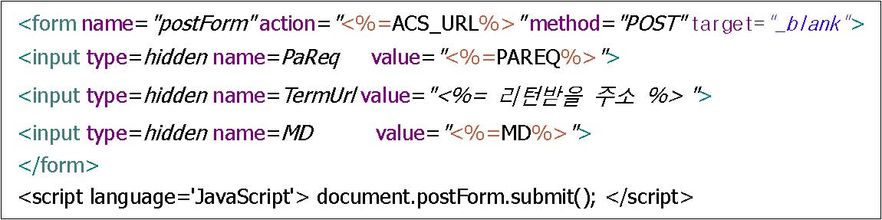

Step 3 > Transmit received Pares value to TermUrl(Address for Merchant to receive Pares) via ‘3.1. Purchase Request’.

3.5.2. HTTPS Request
No | Field Name | Type | Length | Condition | Description
1 | ? | AN | 1 | M | Start Request Refer to 2.1.1.
2 | Ver | AN | 4 | M | 1000 Fixed Refer to 2.1.2.
3 | RequestType | AN | 4 | M | Request Type Refer to 2.1.3.
4 | MID | AN | 10 | M | Merchant ID Refer to 2.1.4.
5 | TransactionType | AN | 2 | M | Transaction Type Refer to 2.1.5.
6 | Reference | AN | 20 | M | Transaction Reference Number (Unique) Refer to 2.1.6.
7 | Currency | AN | 3 | M | Currency Refer to 2.1.7.
8 | Amount | AN | 12 | M | Refund Request Amount Refer to 2.1.8.
9 | CardNumber | V | - | M | Card Number Refer to 2.1.9.
10 | ExpiryYYMM | V | - | M | Expiry Date Refer to 2.1.10.
11 | VerifyValue | V | - | M | Verification Value Refer to 2.1.19.

Example 1:
Request Start | ?
Ver | 1000
RequestType | TRAN
MID | mcausa840m
TransactionType | AQ

Reference | MERCHANT00001234
Currency | USD
Amount | 100.99
CardNumber | 66VwxV18yJtMpx2ynJrituttHeqF4+B/hiN+Wu9uFLY=
ExpiryYYMM | hKWRom2bQB0M1LQWACKwsg==
VerifyValue | ZDJjYjYxNTU2ZDU3YmIzMGJiY2NmMjM 3NzYzN2Q4ZDg5MWMxZmQ3MmIzNjdl NDcyZGE3MzgzYTA0NTdlYTVlNA==

3.5.3. Response
No | Field Name | Type | Length | Condition | Description
1 | Ver | AN | 4 | M | 1000 Fixed Refer to 2.1.2.
2 | RequestType | AN | 4 | M | Request Type Refer to 2.1.3.
3 | MID | AN | 10 | M | Merchant ID Refer to 2.1.4.
4 | TransactionType | AN | 2 | M | Transaction Type Refer to 2.1.5.
5 | Reference | AN | 20 | M | Transaction Reference Number (Unique) Refer to 2.1.6.
6 | ResponseCode | AN | 4 | M | Response Code Refer to 2.1.20.
7 | ResponseMessage | AN | 100 | M | Response Message Refer to 2.1.21.
8 | ResponseDate | AN | 8 | M | Transaction Date Refer to 2.1.22.
9 | ResponseTime | AN | 6 | M | Transaction Time Refer to 2.1.23.
10 | TID | AN | 30 | M | Smartro’s Transaction Number (Unique) Refer to 2.1.24.
11 | AuthCode | AN | 15 | M | Authorization Number (Original Transaction Authorization Number) Refer to 2.1.25.
12 | Acs_url | AN | 1k | M | Verification URl
13 | Pareq | AN | 4k | M | Verification Request value 1
14 | Md | AN | 40 | M | Verification Request value 2
15 | VerifyValue | V | - | M | Verification Value Refer to 2.1.19.

Example 1:

<Response>
<Ver>1000</Ver>
<RequestType>TRAN</RequestType>
<MID>mcausa840m</MID>
<TransactionType>AQ</TransactionType>
<Reference>MERCHANT00001246</Reference>
<ResponseCode>0000</ResponseCode>
<ResponseMessage>Processing Valid</ResponseMessage>
<ResponseDate>20140928</ResponseDate>
<ResponseTime>112500</ResponseTime> <Acs_url>https://dpay.smilepay.co.kr/3dTest?</Acs_url>
<Pareq>?</Pareq>
<Md>?<Md>
<VerifyValue>
ZjQwOGE3MzQyZGY0NzJmNjVhZjc1NzQ0NTc3NjY5YjE4MmM4
Y2IxOGY5Y2U3MDNlMGQ2MTE4ZjZiZDI1OTIwNQ==
</VerifyValue>
</Response>

4. Data Encryption
4.1. Credit Card Data Encryption
4.1.1. Description
Encrypt Credit Card Number, Expiry Date, CVC and other Credit Card Details to transmit Data in safe and secure environment.

4.1.2. Algorithm
Algorithm encryption uses AES 128bit. (Block Mode : ECB Mode, Padding Method : PKCS5)
Refer to 4.1.3 for Key creation method.

4.1.3. Key Creation Method
Smartro provides key that is 88 byte in length to Merchants. When 64byte is divided into 4 blocks, 4 keys are created that can be used in AES 128bit. Under the arranged rules, select 1 key out of the 4 keys and encrypt.

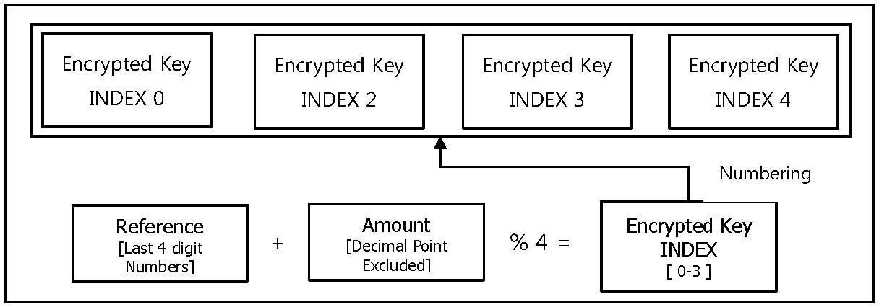
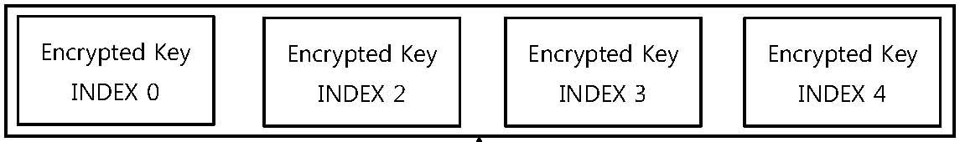

Encrypted Key
INDEX 2
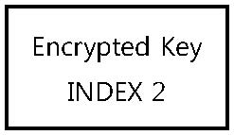
Encrypted Key
INDEX 3
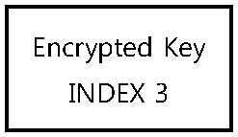
Encrypted Key
INDEX 4
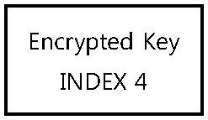
Encrypted Key
INDEX 0
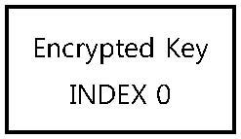

Numbering
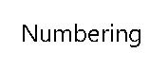

Encrypted Key INDEX
[ 0-3 ]
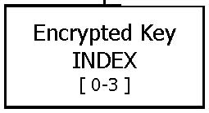
% 4 =
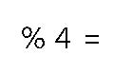
Amount
[Decimal Point Excluded]
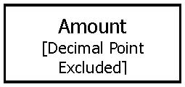
+

Reference
[Last 4 digit Numbers]
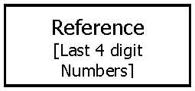

4.1.4. Sample Source

<Java Code>

/* 88 byte Merchant Issuing Key*/
String merchantKey = “Kr1A0sO6GPBw2L/wZ+mDBPSuqGlJeHXEw” +
“ByclfCB2kM0VrTx05cAhhmG8nvadMgLNn3”+ “nuxKC1IGoVN3t27+uVA==”;

/* 64 byte Encrypted Key*/
String secureKey = merchantKey.substring(0,64);

/* Divide 64 byte Key into 16 byte*/
String aesKeyIdx0 = secureKey.substring(0,16);
String aesKeyIdx1 = secureKey.substring(16,32);
String aesKeyIdx2 = secureKey.substring(32,48);
String aesKeyIdx3 = secureKey.substring(48);

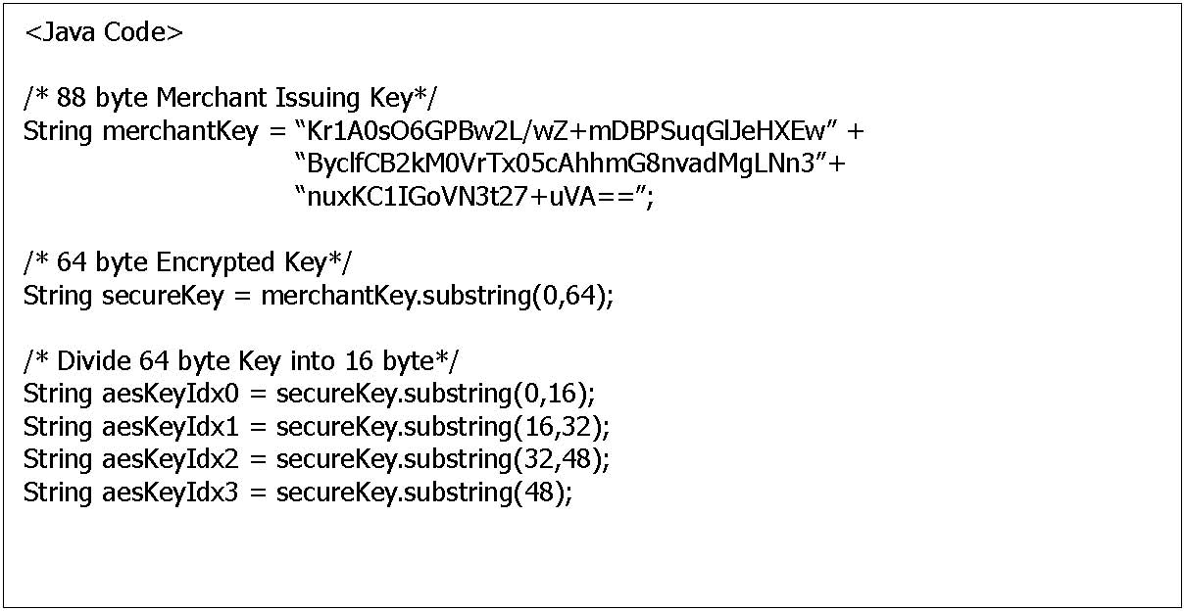

/*
When Reference = MERCH123456, Amount = 5.95
Use 3rd index Key(aesKeyIdx3) as the remainder after dividing into 4 is 3
*/
int idx = ( 3456 + 595 ) % 4 = 3

/*
Encode Base64 with the created Encrypted Key after encryption with AES encryption Algorithm
*/
String encyptResult = new String(BASE64.encodeBase64(${Data Encryption}));
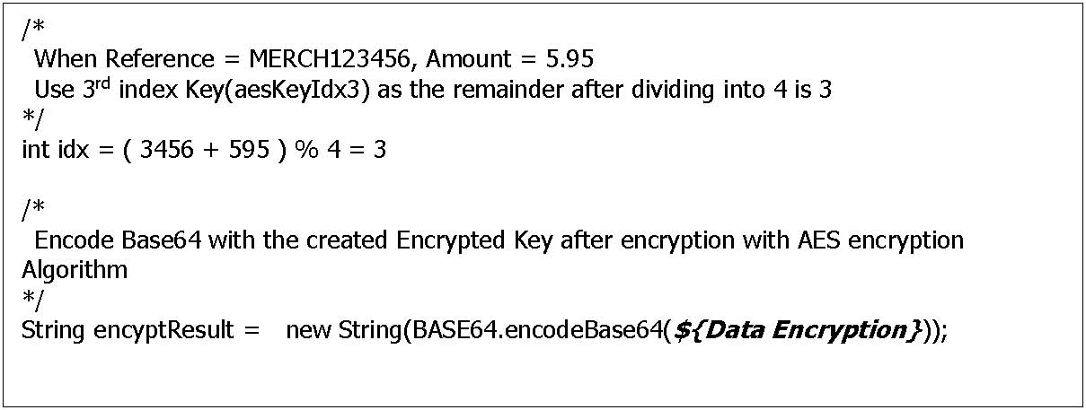

4.2. Forgery/Alteration Data Verification
4.2.1. Description
Create data to verify forgery/alteration from Request/Response data based on rules set for each services.
[Refer to 2.1.19 VerifyValue]

4.2.2. Algorithm
SHA 256 Hash Algorithm is recommended for use. If the language does not support, the created data (as created based on the rules set for each services) is to be sent as it is.

4.2.3. Method to create Data
Create data to verify forgery/alterations from Request/Response data based on rules set for each services.
Data is composed by selecting entry from request and/or response data and connecting entries with created delimiters.
As how encrypted key is created, same follows when delimiters are created by using Reference and key issued to Merchant.

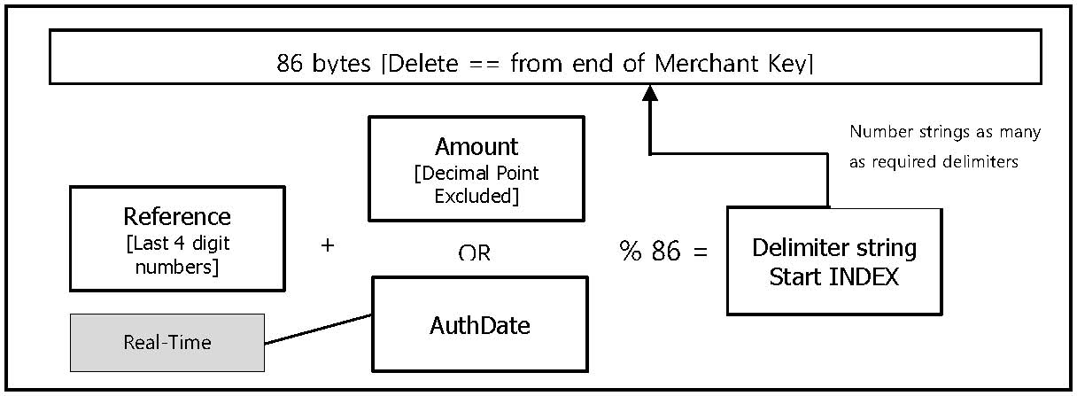
86 bytes [Delete == from end of Merchant Key]

Number strings as many as required delimiters
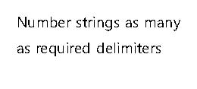
Amount
[Decimal Point Excluded]
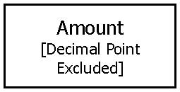

Reference
[Last 4 digit numbers]
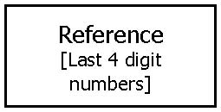

OR
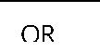
Delimiter string Start INDEX
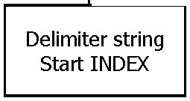
% 86 =
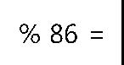
+


AuthDate
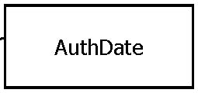


Real-Time Capture
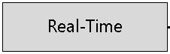

4.2.4. Sample Source

<Java Code>
// create VerifyValue when requesting purchase

/*
Reference = MERCH123456, Amount = 5.95, MID = mcausa840m, AcquireType = 1
*/

/* Use 86 byte from Merchant issued key(Delete “==”) */
String merchantKey = “Kr1A0sO6GPBw2L/wZ+mDBPSuqGlJeHXEw” +
“ByclfCB2kM0VrTx05cAhhmG8nvadMgLNn3”+ “nuxKC1IGoVN3t27+uVA”;

/*
When Reference = MERCH123456, Amount = 5.95
INDES is 9 as the remainder after dividing in 86 is 9
*/
int idx = ( 3456 + 595 ) % 86 = 9

/*
When requesting purchase, three delimiter 3 byte are required. (9 byte extracted from Start INDEX 9)
※ Like Java, add 1 to response value when Start INDEX is 1 not 0.
※ When data is extracted from Start INDEX and the data is lacking at the end, extract from the front for the lacking data.
*/
String delimiters = merchantKey.substring(9,18); // (int idx may vary based on Amount and Reference; total 9 byte length)

/*
Create Data (Encode BASE64 for each element)
If SHA 256 Hash is invalid send below data
*/
StringBuffer buffer = new StringBuffer();
buffer.append(Base64.encodeBase64(“MERCH123456”.getBytes())); //Reference
buffer.append(delimiters.substring(0,3)); // First delimiter (3 byte)
buffer.append(Base64.encodeBase64(“5.95”.getBytes())); // Amount
buffer.append(delimiters.substring(3,6)); // Second delimiter (3 byte)
buffer.append(Base64.encodeBase64(“mcausa840m”.getBytes())); // MID
buffer.append(delimiters.substring(6,9)); // Third delimiter (3 byte)
buffer.append(Base64.encodeBase64(“1”.getBytes())); // AcquireType

/*
Apply if SHA 256 Hash is valid (SHA 256 ⇒ Hex ⇒ Base64 )
*/
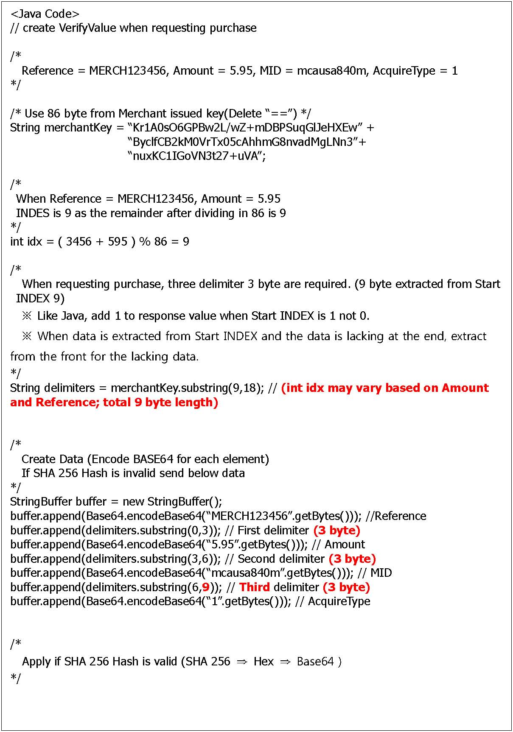

MessageDigest sha256 = MessageDigest.getInstance("SHA-256");

sha256.update(buffer.toString().getBytes());

byte[] hashResultBytes = sha256.digest();

String verifyValue =
new String(Base64.encodeBase64(new String(Hex.encodeHex(digest)).getBytes()));
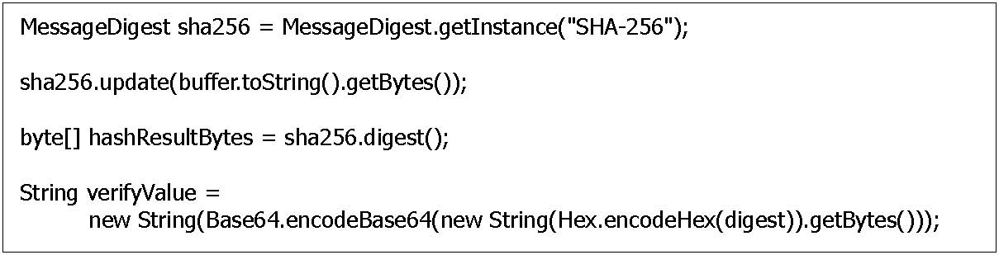

APPENDIX I. Response Code/Message
Code | Message
0000 | Processing Valid
E901 | VAN communication Error
G001 | Unregistered Merchant
E900 | Invalid Transaction - Others
G002 | PG Basic Information Error
G003 | Terminal ID Error
E902 | Invalid Transaction Cancellation
E903 | Transaction Date mismatch
E904 | Purchaser Serial Number Error
E905 | Transaction Specification Form Error
E906 | Please enquire International Brand Company
E907 | Amount Error
E908 | Original Transaction Amount
E909 | Cancelled Transaction
E910 | Invalid part cancellation
E911 | Expiry Date Error
E912 | Installment Month Error
E913 | Installment Amount Error
E914 | Settlement Transaction
E915 | Non-existent Original Transaction
E916 | Transaction Restricted Merchant
E917 | Card Number Error
E918 | Password Error
E919 | Password input limit exceeded
E920 | Transaction Suspended Card
E921 | Insufficient Funds
E922 | Merchant Limit Exceeded
E923 | Expired expiry date
E924 | Cardholder Limit Exceeded
E925 | Lost/Stolen Card
E926 | Unregistered Password
E927 | System Error
W003 | Merchant Data Search Failure
W004 | Invalid Currency Code
W006 | Verification Key creation Failure

W007 | Forgery/Alteration Verification Failure
W008 | Code Decryption Failure
W009 | Communication Failure
M001 | Inserted invalid card number
M002 | Please insert CVV number
M003 | There is no card holder information
M004 | This card is suspended
M005 | This card is stolen card
M006 | This card is expired
M007 | Amount limitation excessed
M008 | Failed CVV verification
M009 | This card cannot be used
M010 | Call card issuer
M011 | Daily amount limitation excessed
M012 | Monthly amount limitation excessed
M013 | Maximum amount limitation excessed
M014 | Amount is under minimum limitation
M015 | Manual acquiring
M016 | There is something missing on requesting
M017 | Does not fit on requesting data
M018 | Transaction category is wrong
M019 | Merchant is not registered
M020 | Transaction password does not match
M021 | This merchant cannot do live processing
M022 | Not registered service URL
M023 | not on service area
M024 | Original transaction information does not exist
M025 | Processing amount is wrong
M026 | Does not match with Approval processing currency
M027 | This transaction is already cancelled
M028 | This transaction is already refunded
M029 | This transaction is declined
M030 | Transaction ID does not exist
M031 | This merchant order number does not exist
M032 | Merchant server timed out
M033 | Requesting time expired
M034 | Transaction data verification has been failed
M035 | Database error 1

M036 | Database error 2
M037 | This card cannot be approved
M038 | Acquirer error
M039 | Cannot identify this transaction

